# **Use Case Model and description**

In the below section, it will include the use case model for the HungrySpoon mobile application as well as the use case description for the key functionalities

## **Use Case Model**



Figure - Use Case Diagram for HungrySpoon

## **1.2 Use Case Description**

### **1.2.1 Account creation**

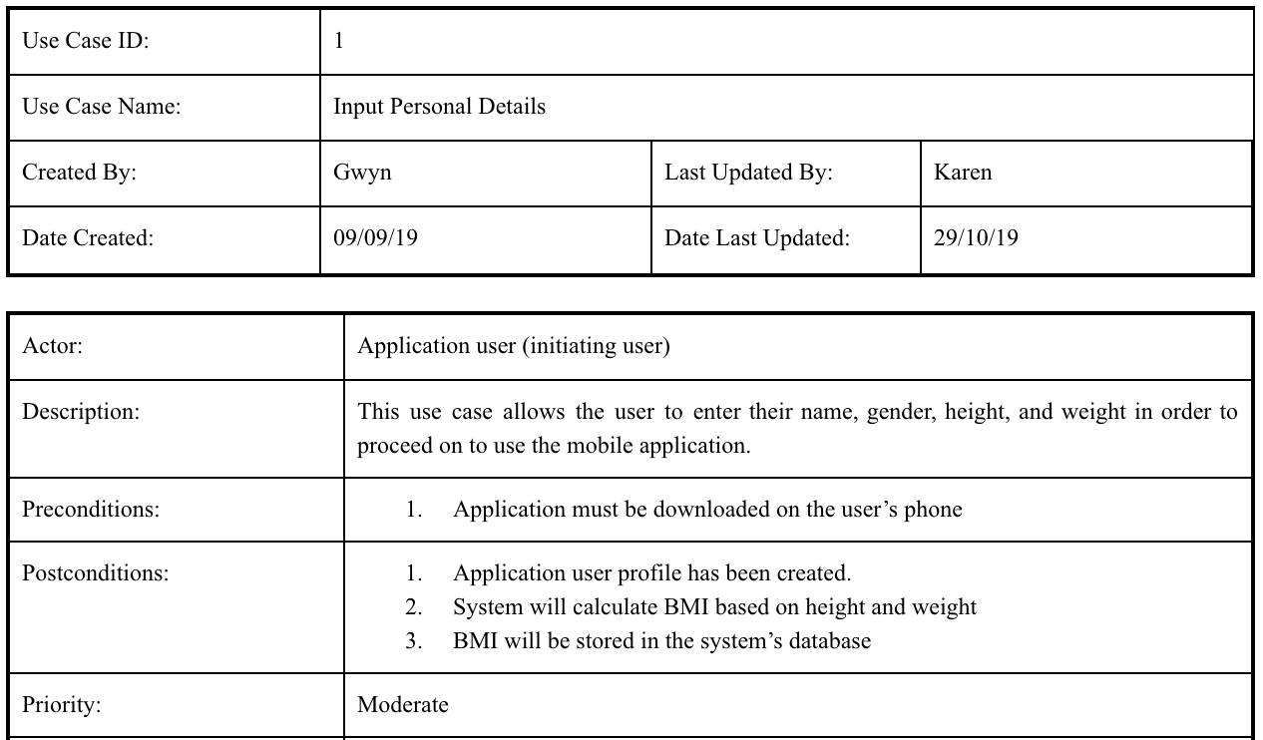

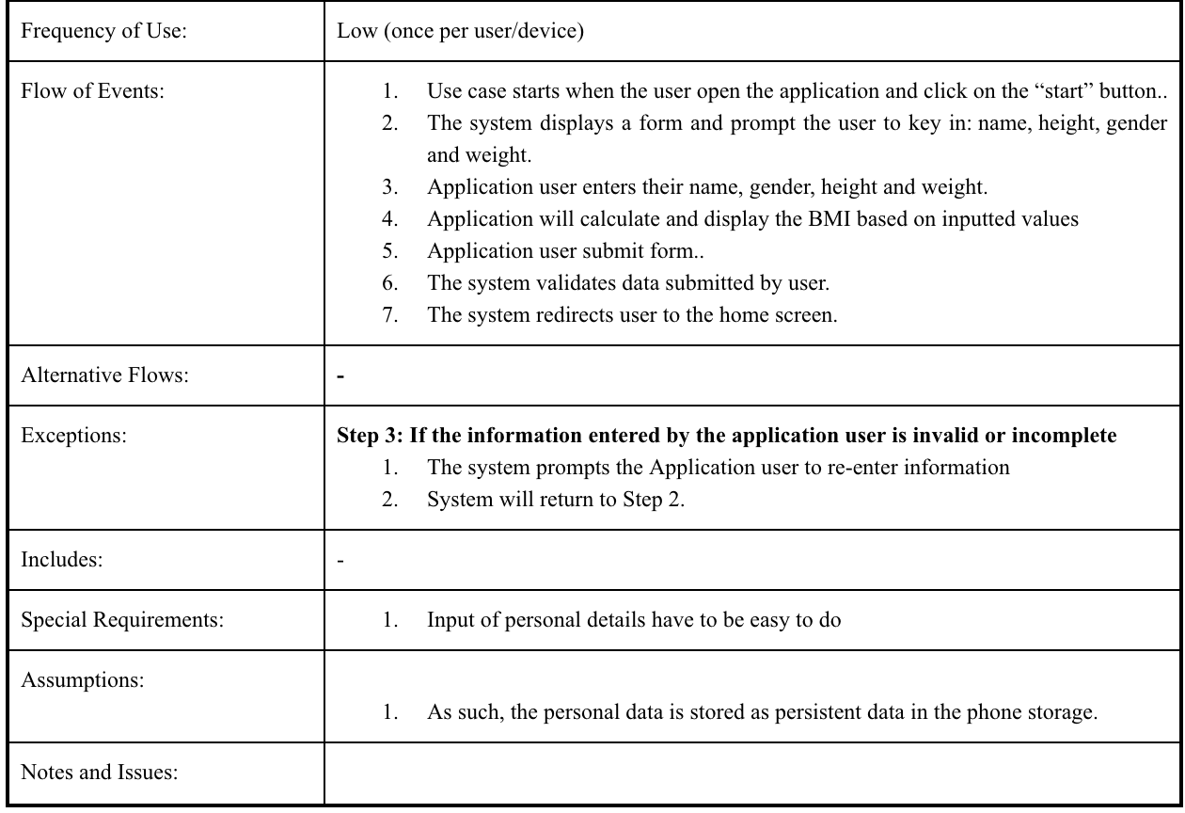

### **1.2.2 Update account details**

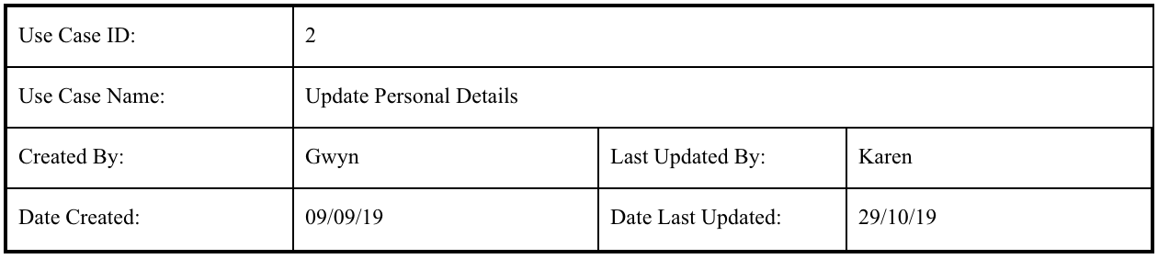

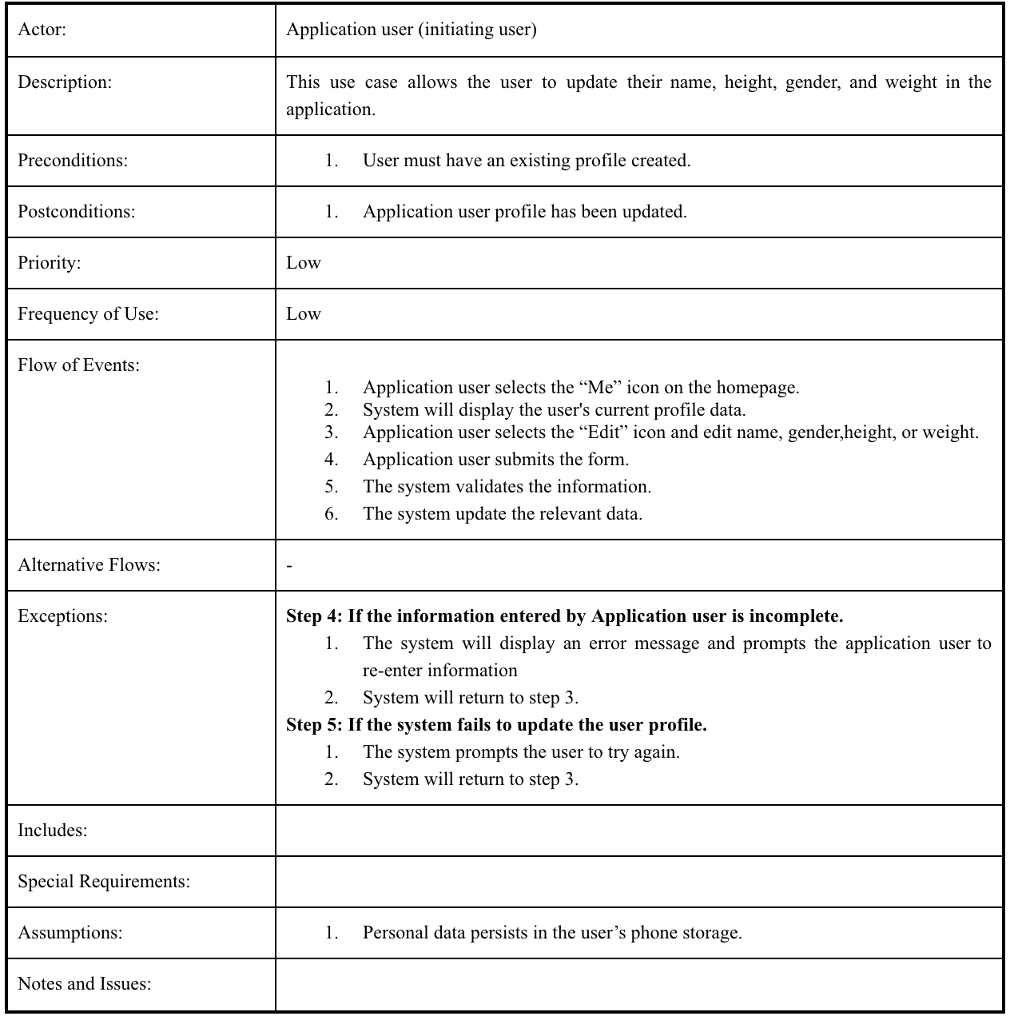

### **1.2.3 Food generator**

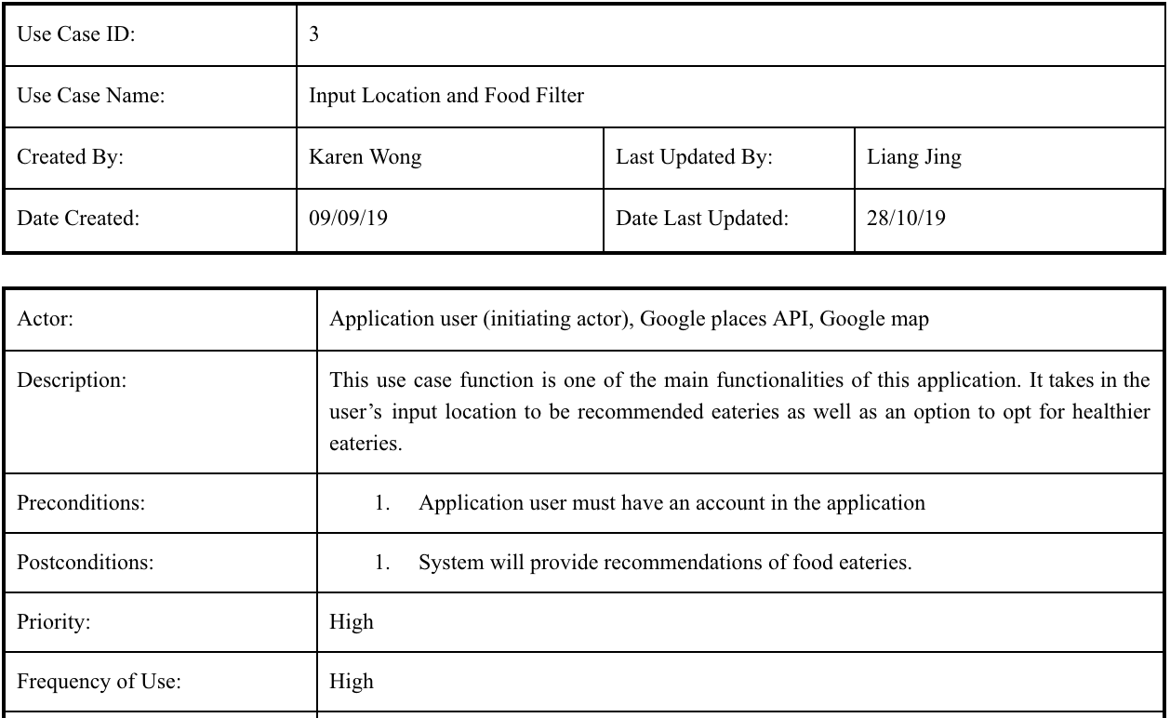

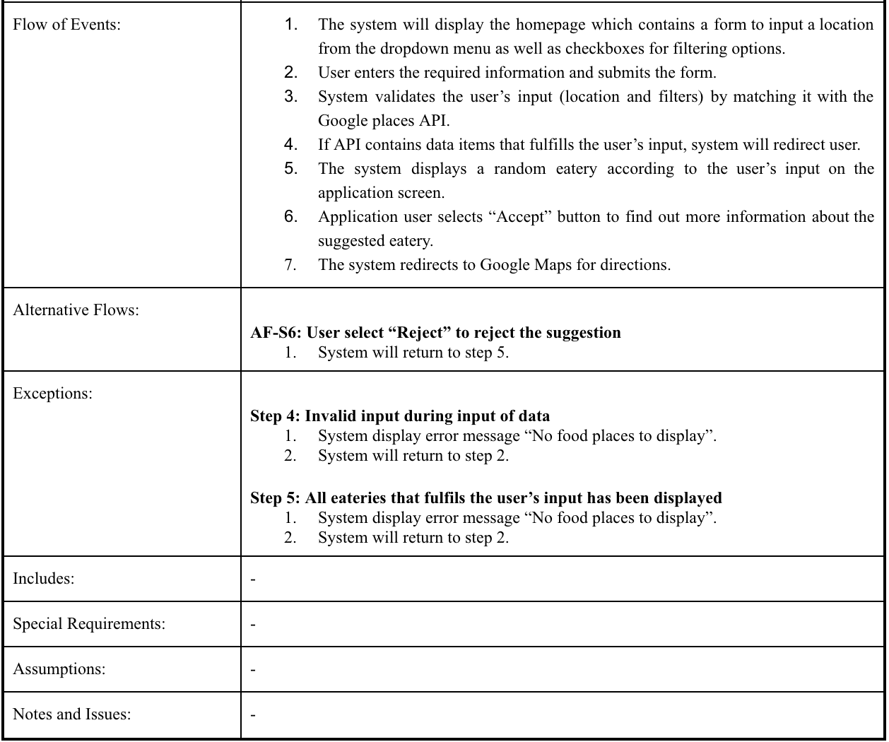

### **1.2.4 Locating Parks**

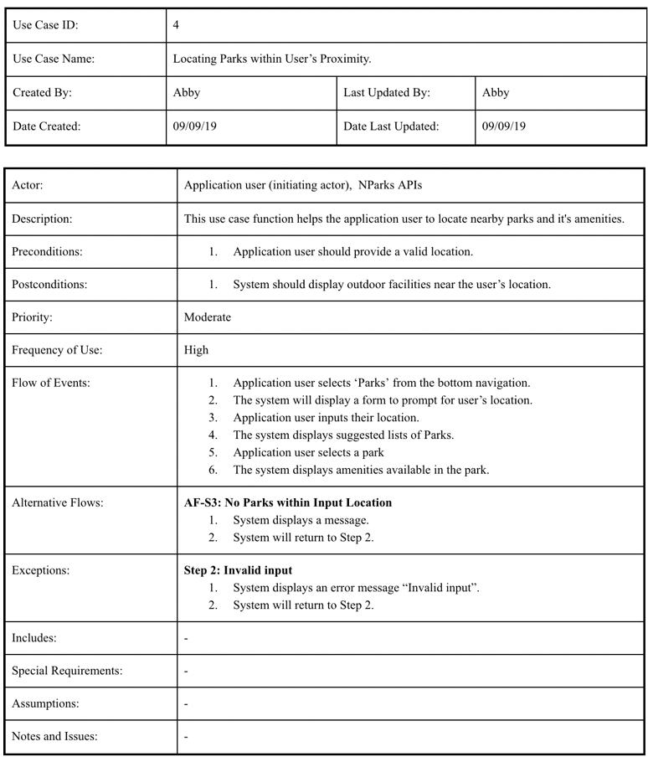

### **1.2.5 Calories counter and Exercise Recommendation**

